CS2106 - Data Structure and Algorithms 17.12.2024 Time:60minutes

Question 1: Game Event Processing (Queue)
Scenario:
You are managing a game server that processes player actions. Actions arrive in a sequential order, and the system must process them in the same order (FIFO).
Task:
Implement a queue data structure to simulate action processing.Define the following operations:
- enqueue(action): Adds a player action to the queue.
- dequeue(): Processes the oldest action in the queue and removes it.
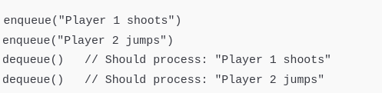

Question 2: Dungeon Escape (Stack)
Scenario:
In a dungeon crawler game, players need to keep track of rooms they've visited. Each room leads to other rooms, and players can use a Stack to backtrack to previous rooms if they hit a dead end.
Task:
- Use a stack to implement the player's movement between rooms.
- The following operations should be supported:
- visitRoom(roomName): Push a room to the stack (mark as visited).
- backtrack(): Pop the current room to go back to the previous one.
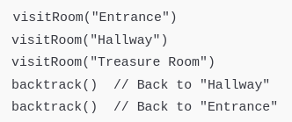

Question 5: Battle Queue (Queue)
Scenario:
In a multiplayer game, players are waiting in a queue to battle in a tournament. The server processes them in a First Come, First Serve manner.
Task:
Implement the tournament queue using a queue data structure.
Define the following operations:
joinQueue(playerName): Add a player to the queue.
startBattle(): Start a battle with the first player in the queue and remove them.
